4.1: a) For the magnitude of the sum to be the sum of the magnitudes, the forces must be parallel, and the angle between them is zero. b) The forces form the sides of a right isosceles triangle, and the angle between them is 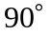. Alternatively, the law of cosines may be used as
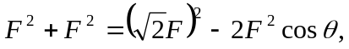
from which 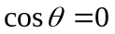, and the forces are perpendicular. c) For the sum to have 0 magnitude, the forces must be antiparallel, and the angle between them is 

